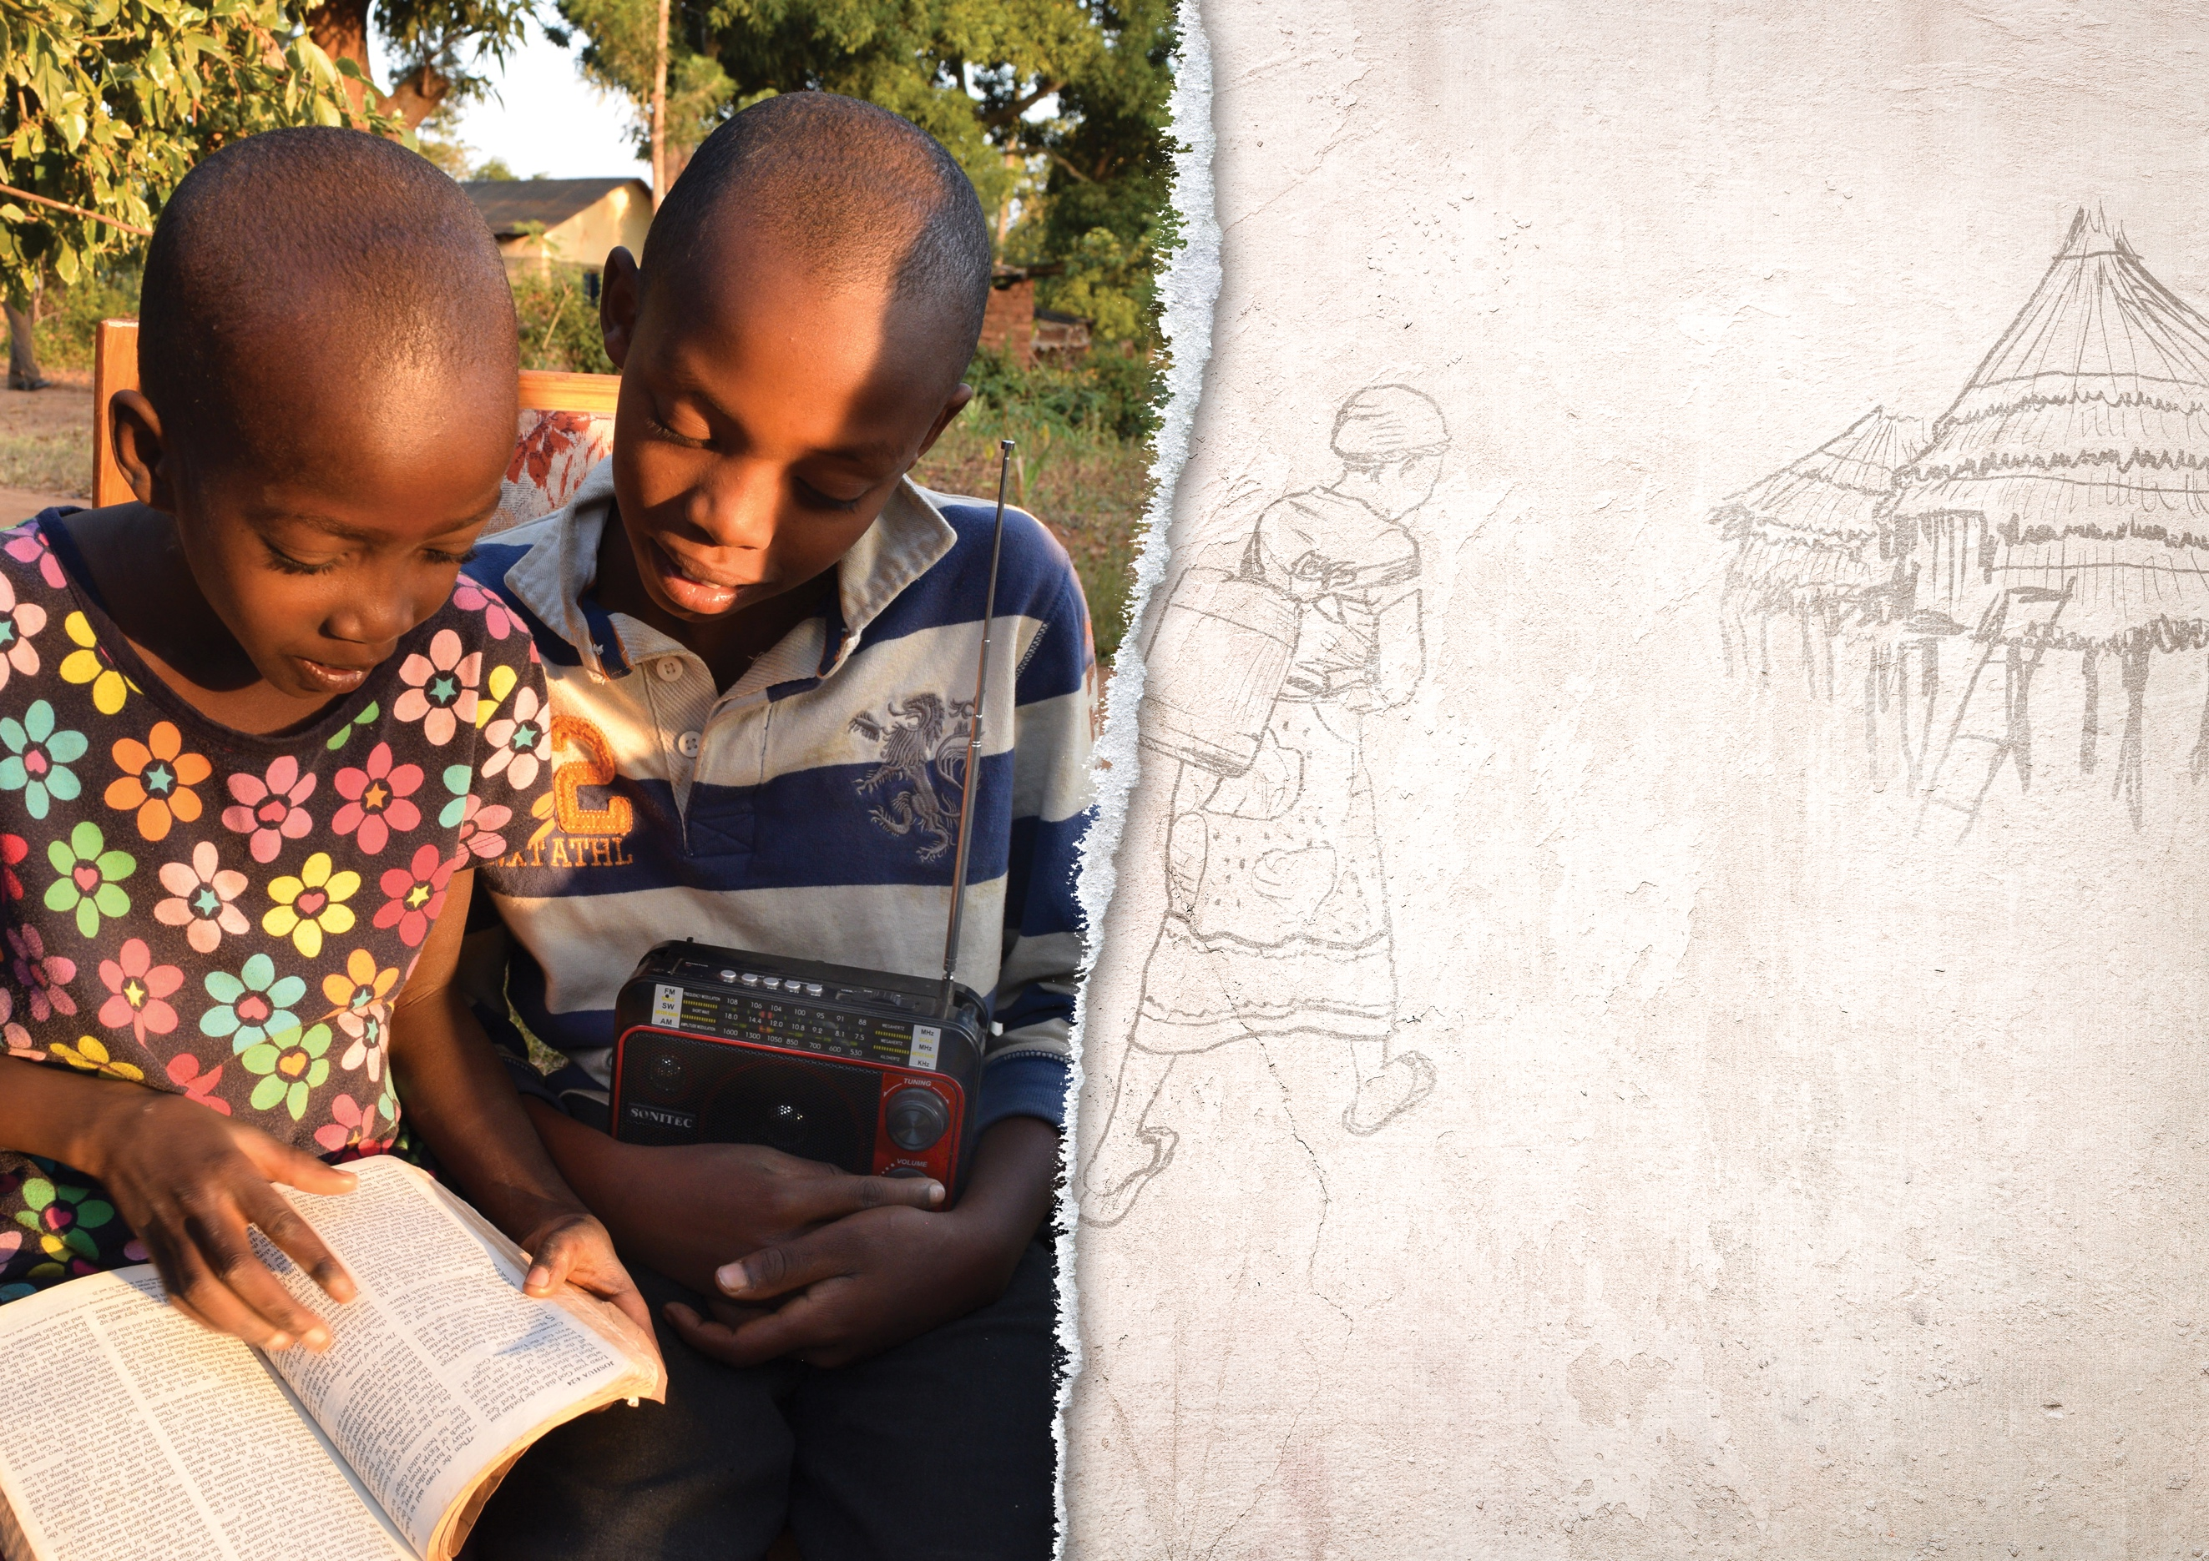V

Your Mission Radio

Global podcasts • Regional shortwave • Local AM/FM • 100+ Languages

Annual Offering

March 11, 2017

“Your biblical messages are turning out to be a great blessing for me; my faith   
is strengthened. I want my children   
to grow up for Jesus.” — AWR Listener