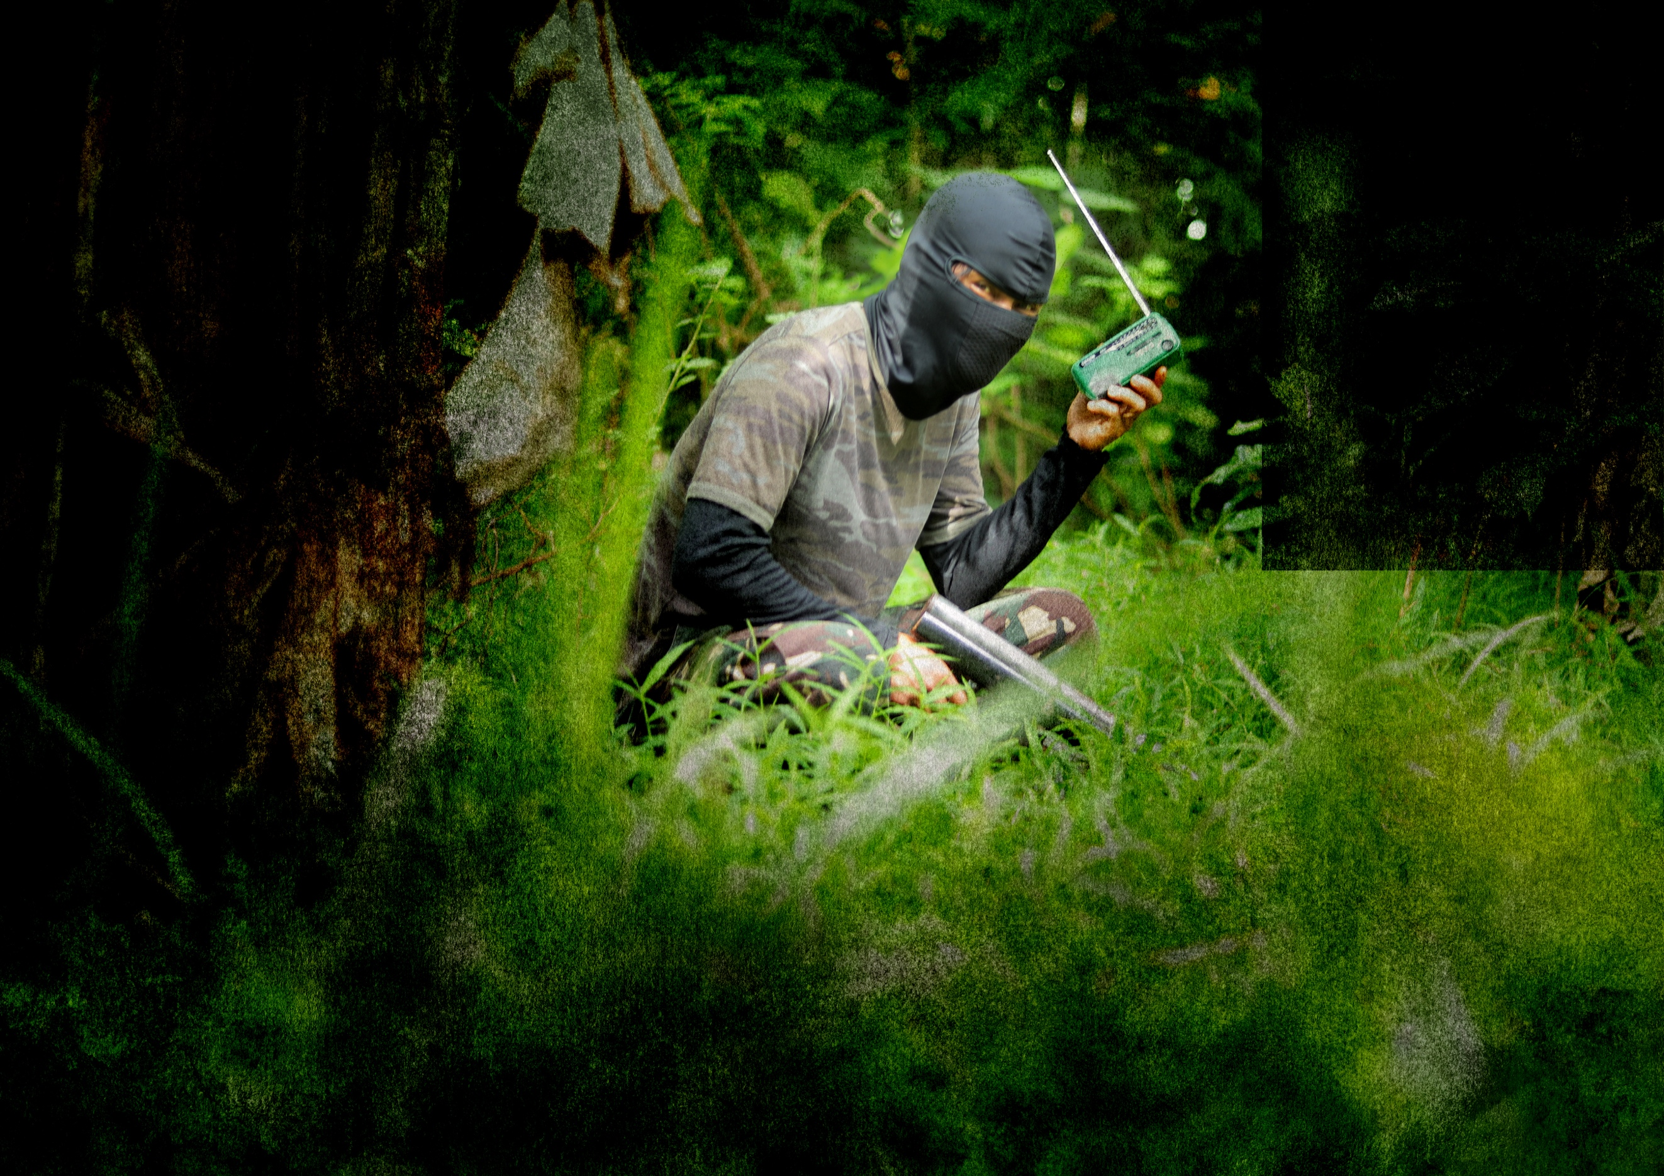V

AK-47

EXCHANGING AN

FOR A

Bible**?**

Yes, 65 communist rebels in the Philippines started new lives in Christ last year … directly from the hope and courage they found in AWR’s broadcasts. Your offering will send the gospel to more hard-to-reach listeners around the world.

No walls.

No borders.

No limits.

**GLOBAL PODCASTS • REGIONAL SHORTWAVE • LOCAL AM/FM • SOLAR PLAYERS • CELL PHONE EVANGELISM • SOCIAL MEDIA • 100+ LANGUAGES**

**ANNUAL OFFERING**

ADVENTIST WORLD RADIO

MARCH

2019

9

12501 OLD COLUMBIA PIKE

SILVER SPRING, MARYLAND 20904 USA

|  |  |
| --- | --- |
|  | 800-337-4297 |
|  | AWR.ORG |
|  | @AWR360 |
|  | /AWR360 |
|  | AWR.360 |